Documentation For ShopMax

!. Added Calender Widget on Start Date and End Date on create_promo_free_shipping.html page

URL: http://shopmax.stpreview.com/pages/create_promo_free_shipping.html

At the bottom of this page there are two fields Start Date and End Date. When user clicked on the text field as well as the calender thumbnail the calender will be displayed to choose the date.

At first we include the CSS and Javascript's of datepicker functionality at line no's 27,56,57,58 in create_promo_free_shipping.html page.

Start Date

A unique ID is given to text box and image taz at line no 422 and 425 for Start Date. When the user click on the input box and the calender thumbnail of Start Date a javascript runs which is at line no from 73 to 80. That script picks the ID of Text Box and Image tag of Start Date and through that ID a datepicker() function on Line no 75 runs that displays the calender at the desired ID location. And when user click on calender thumbnail a click() runs at Line no 76. click () runs through the ID we gave to image tag at line no 425. Then the ID of text box is used to run the datepicker(“show”) here datepicker is the function and show is the command at line no 77 to display the calender on the screen.

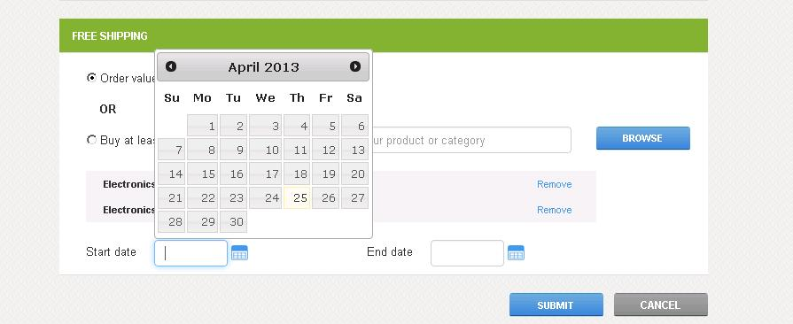

End Date

A unique ID is also given to the text box and image tag of End Date which is at line no 428 for text box and 431 for image tag.When user click on the End Date text box and calender thumbnail a javascript runs which is at Line No 83 to 90 and performs the similar function as defined above for Start Date.

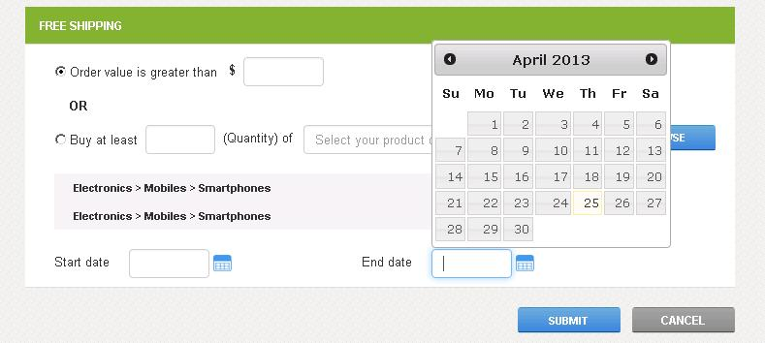

2. FancyBox Displayed on click of Browse Button on create_promo_free_shipping.html page

URL: http://shopmax.stpreview.com/pages/create_promo_free_shipping.html

Here at first we included the CSS and Javascript of Fancybox at line no from 44 to 52 these files are at the desired path specified.

e.g. <script src="js/fancybox/source/jquery.fancybox.pack.js"></script>
this file path is at the root goes to folder name js ->and then it goes to the subfolder fancybox then it goes to subfolder source from this subfolder you can find the jquery.fancybox.pack.js file

Then we apply the HTML part which we want to display on the FancyBox that is at line no 102 to 201 and we also gave a Unique ID at line no 202 at div tag and we passed that ID to the href tag at line no 401 <a href="#inline3" class="btn-general-small12">Browse</a>
and we also gave a Unique ID to the a href tag at line no 401 <a id="various3" href="#inline3" class="btn-general-small12">Browse</a> so when the user clicks on the browse button a scripts runs which is at line 62 to 71. here we used the ID which we gave at line no 401 to pop up the fancybox and the ID which we passed at line no 401 at href tag is searched and that home html part will be displayed on the Fancybox.

Fancybox on Browse Button Click

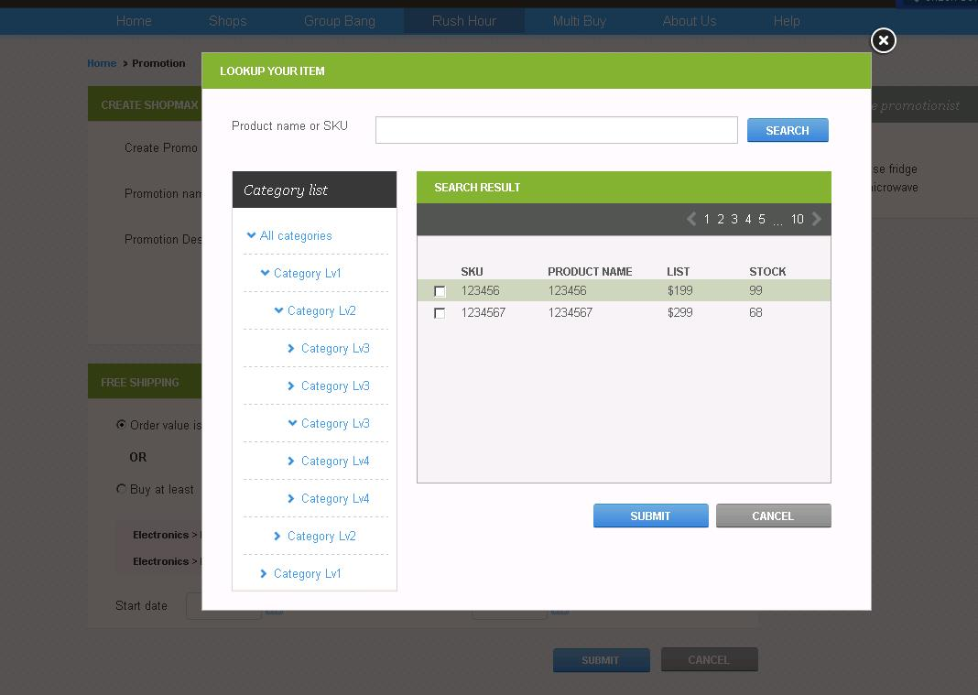

3. Google Address Suggestions on Two pages on Search_list_view.html and Search_grid_view.html

URL: http://shopmax.stpreview.com/pages/Search_list_view.html

URL : http://shopmax.stpreview.com/pages/Search_grid_view.html

When we type in the search box the Dynamic Google Address Suggestions will be displayed to the specific country.
Here in search box a ID is given at a Line No 250 on Search_grid_view.html page so when user types something a Script will run which is at Line No 252 to 276. here in this script at line no 266 the componentRestrictions Country is used to display the search related to specific country we can also change this too.

e.g. componentRestrictions: {country: 'nz'} // It displays the Address Suggestions related to NewZealand only

and if we want to change it.
componentRestrictions: {country: 'in'} // // It displays the Address Suggestions related to India only

The document.getElementById('address'); at line no 269 is used to fetch the text we typed on text box this is fetched using the ID which we gave at line no 249 and then the google maps event is performed at line no 272 that displays the google address suggestions dynamically.

Grid View Search

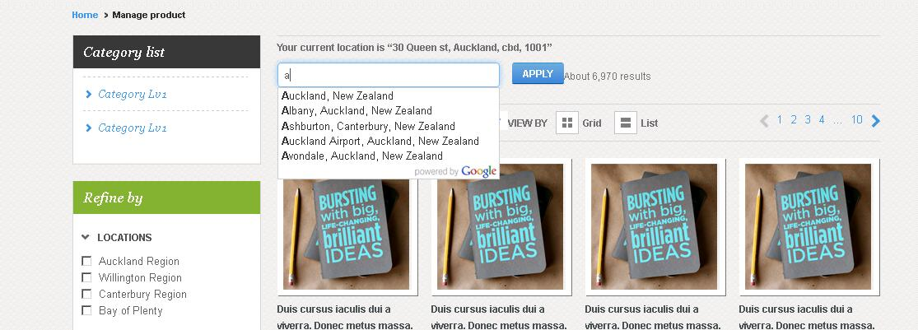

List View Search

Here in search box a unique ID is also given at a Line No 535 on Search_list_view.html page so when user types something a Script will run which is at Line No 538 to 552.
The componentRestrictions is at line 543 functionality as defined above.

The document.getElementById('address111'); at line no 546 is used to fetch the text we typed on text box this is fetched using the ID which we gave at line no 535 and then the google maps event is performed at line no 548 that displays the google address suggestions dynamically.

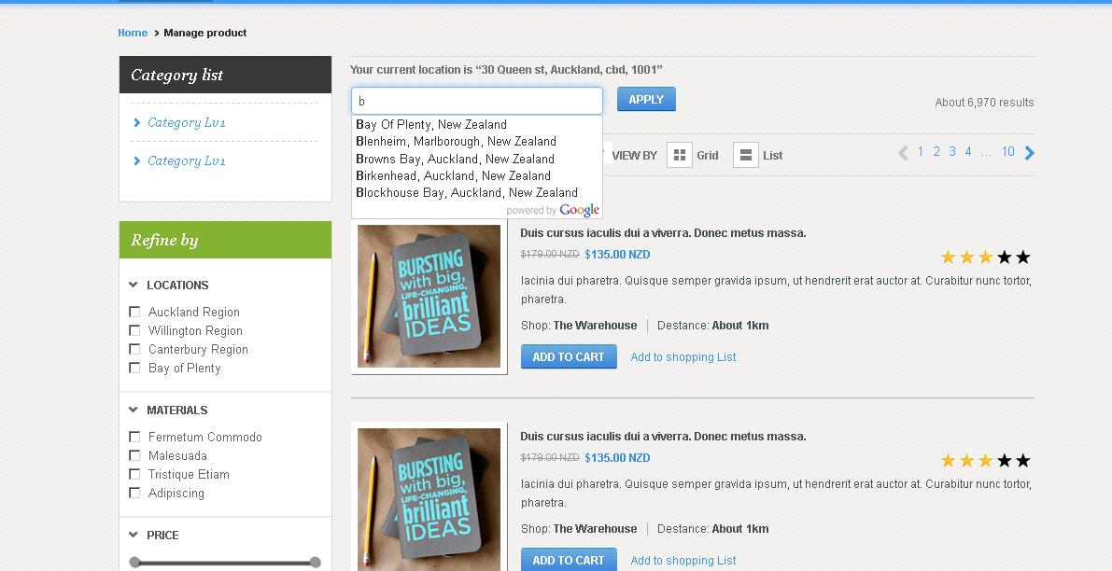

4. Dynamic Google Map Displayed on shop_aboutus.php page

URL: http://shopmax.stpreview.com/pages/shop_aboutus.php

Here in Shop aboutus page a Dynamic google map will be dispalyed on the page if we change the address then the New Address Location Map will be dispalyed.

At first we set up the variables like the height and width of the iframe in which the google map will be displayed at line no 212 and 213 on shop_aboutus.php page and then at line no 215 we put the address of the location which we want to display on the map. From this line 215 we can change the address location and dynamically the google map location will be changed.

We also need Google maps API Key which we specified at line no 217. we need this because we are using google maps services to showing the maps.

Then at line no 218 we passed Address Variable and Api Key variable
$url = "http://maps.google.com/maps/geo?q=".$address."&output=json&key=".$key;

from the specified address it will calculate the coordinates points of latitude and longitude.
And in line no 242 the iframe tag we used and passed the width, height variable and in between the iframe tag we displayed the Address , Latitude and Longitude .which is used to display the map.

Dynamic Google Map

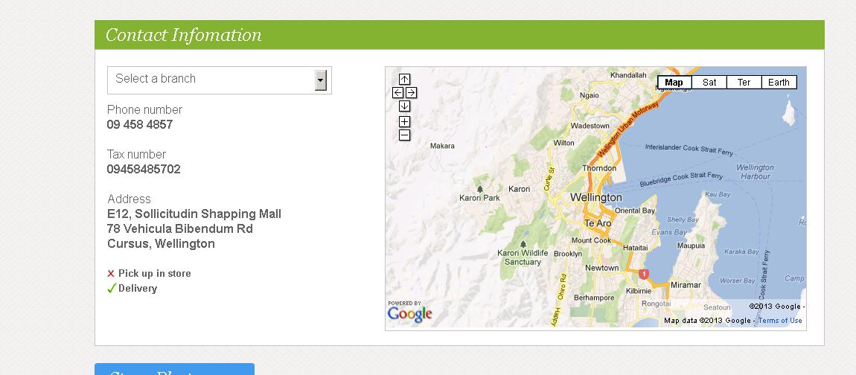

5. Image was not displaying in proper way in Browsers.

URL: http://shopmax.stpreview.com/pages/my_account.html

Height was not given in .preview class at line no 70 in my_account.html page. We give height at line no 73 to display the image in proper way.

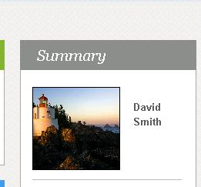

6. Slider Issues on Two pages in group-bang.html and product_details_groupbang.html

URL : http://shopmax.stpreview.com/pages/group-bang.html
URL : http://shopmax.stpreview.com/pages/product_details_groupbang.html

(a). Slider Pointer height increased from top and bottom.

Slider pointer height was not enough from the top point and from the bottom point so we increased the height at line 309 and top at line 310 on group-bang.html page to increased the pointing lines height from top and bottom.

Similarily all the slider pointers height at different locations in this group-bang.html page at line 516, 517 for second slider. At Line No 664,665 for the third slider. At Line No 802, 803 for the fourth slider on group-bang.html page .

And on product_details_groupbang.html page at line no 530 and 532 slider pointer height increased.

(b). Slider pointer buyers value displayed at above the pointing Line and it should be at the center of the pointer Line.

At product_details_groupbang.html page on line no 321 in style tag we increased the to top: -49px;
so that the buyers value should displayed above the pointer.
And to display the Buyers value at the center of the pointer at line no 328 first we used the string replace function to replace the 'px' with '' i.e. blank.

e.g. lvals=lvals.replace("px",""); // the value in lvals i.e. 'px' is replaced with ''

and in Line no 334 and 336 we subtracted 39 and 25 from lvals variable and concatenate 'px' with them to move it left at desired position. So that it should displayed at the center.

We followed this procedure at group-bang.html page at Line No 308, 312 , 314 and 354 for first slider. Line No 508,515,519and 520 for second slider. Line no 556,563,567 and 569 for third slider. Line no 794,801,805 and 807 for fourth slider on group-bang.html page.

C. Slider was not showing the exacat Buyers and Price related to that buyers.

There was issue in the slider image the margin between each buyers from 1 to 10 , 10 to 20 , 30 to 40 and 40 to 50 Buyers was different thats why it was not showing the exacat values on selection. So we fixed the image problem so that the margin space between each Buyers will be equal.

Slider

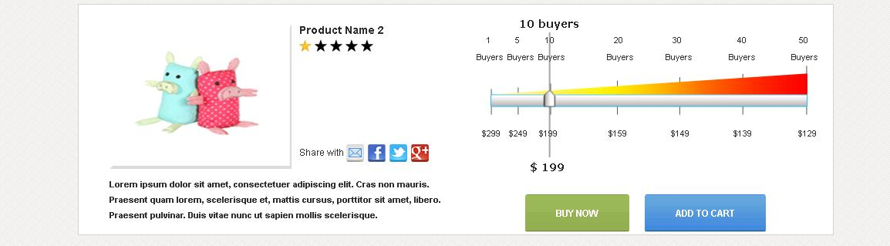

(d). The Static Values 1,5,10,20,30,40, 50 and Buyers on Top of Slider and the Price values $299,$249,$199,$159,$149,$139and $129 are displayed in center of the pointing line on product_details_groupbang.html page and group-bang.html page.

At line No 246 to 260 on group-bang.html page at each <td style:”left:15px;> tag value increased or decreased so that the Static values displayed in proper alignment for first slider.

At line no 431 to 443 for second slider. Line No 579 to 592 for third slider and Line No 722 to 732 for fourth slider on group-bang.html page.

Similarly on product_details_groupbang.html page at Line No 240 to 255 to make the alignment of static values in proper way.

(e). Change the slider position on group-bang.html page and product_details_groupbang.html page

At Line No 290 you can change the slider position
e.g. if I at line no 290 on group-bang.html page var value1=30; then the slider will moved to the 30 location on the slider image. So if you wants to change then change it from line no 290 for first slider. Line no 453 for second slider. Line no 601 for the third slider. And Line No 739 for the fourth slider on the group-bang.html page

Similarily you can change the slider position on the product_details_groupbang.html page At Line No 266 .

